Line following robots

Ondřej Staněk, ostan89@gmail.com
Gymnasium Na Vítězné pláni, Praha 4, Czech Republic

Abstract
Robotics is not only for scientists. It’s a very interesting and enjoyable way to introduce you to the world of electronics. This paper will show how to build a self-made autonomous robot capable of following a guiding line. An easy principle on how the robot follows the line will be explained. This paper will describe how infrared sensors work and how to process their signal by a microcontroller, which is the brain of each robot. Also the practical side of designing and making a robot’s printed circuit board will be mentioned.

KEYWORDS
line following, programming, Atmel microcotrollers, AVR-Assembler, infrared sensors, a design of a printed circuit board

1 INTRODUCTION
The main idea of my work was to design and put together an autonomous robot, which would be capable of following a black guideline in an unpredictable and unknown environment. The robot could avoid obstacles of certain dimensions on its way. It would be controlled by a differential steering system resembling a tank movement. The guideline and obstacles on the way would be detected and located thanks to a set of infrared sensors whose signals are thoroughly analysed and processed in the Atmega8 microcontroller [11] evaluation. The robot would be equipped by an ISP interface [9] for an easy and prompt computer programme recording. It would be possible to stear the robot by an ordinary IR Remote Control.

1.1 motivation
For building this robot I was motivated by the projects exhibition “SCIENCE”, which was organized by MFF UK in Prague. My first idea was to improve the caterpillar-wheeled vehicle. I wanted this toy to be controlled by the computer. I found the inspiration on the website of the project Lunochod [1].
The more I got into the problem of computer controlling, the more I was fascinated by the possibility of building my own autonomous robot. Finally I decided that I will not connect the computer with the vehicle, but I will put a microcomputer directly into the vehicle instead...

1.2 programming of microcontrollers
When I decided to built the robot, I have not had any experience with microcontrollers (MCU) yet and the only knowledge that I had was from a course in electrotechnics and from help from my grandfather. During the summer holidays I read books about logical integrated circuits [4], [5], programming of microcontrollers [6] and I started with the low-level programming language - assembler. Understanding the instruction of assembler and the MCU architecture is essential. Fortunately there are many examples of simple applications in assembler for MCU ATmega8 on the Internet: [12], [13].
The most difficult step for beginners is to make the MCU programmer work (it means connecting the MCU with PC, compiling and then copying the program into the MCU). I found many wiring schemes from the simplest ones with few resistors to complicated constructions. I have chosen a light hardware programmer [9] in combination with software programmer PonyProg [10] and a development system AVR for writing the program code and compiling. Both programs are available for free. The first time when the programmer did not work, it was very difficult for me to find out if the fault is in the MCU, hardware programmer, LPT port, driver, operation system or even in the configuration of PonyProg. The situation was made more complicated by the fact that not all programmers are compatibile with the given MCU or computer. After several days I solved the problem – the LPT port was blocked by a Cannon printer driver. Everything worked well after I terminated the printer driver. That was the biggest trouble I experienced during the whole process of robot construction.
In my first experiments with the ATmega8 the solderless breadboard showed to be very good because it allowed the changing of wiring of the components easily. Atmega8 processor is programmed through ISP interface and so it is not necessary to disconnect the processor from the circuit during programming. That increases the speed of application development. Firstly I improved my knowledge of assembler by lighting LED diods with MCU. After that I started building my first robot.

2 HOW I CONSTRUCTED MY first ROBOT
My first robot had a caterpillar chassis built from Lego Technic brick-box. Caterpillar tracks were propelled by two independently working engines. It is not possible to power the engines directly from MCU (in comparison to LED diods) because engines need a higher current and it could cause damage to the MCU. Except from the damage it would not allow reversed rotation of motors (DC motors’ sense of rotation depends on polarity of current supply). That’s why both motors are controlled by double H-Bridge L293D [3], which is connected to the MCU by four pins.

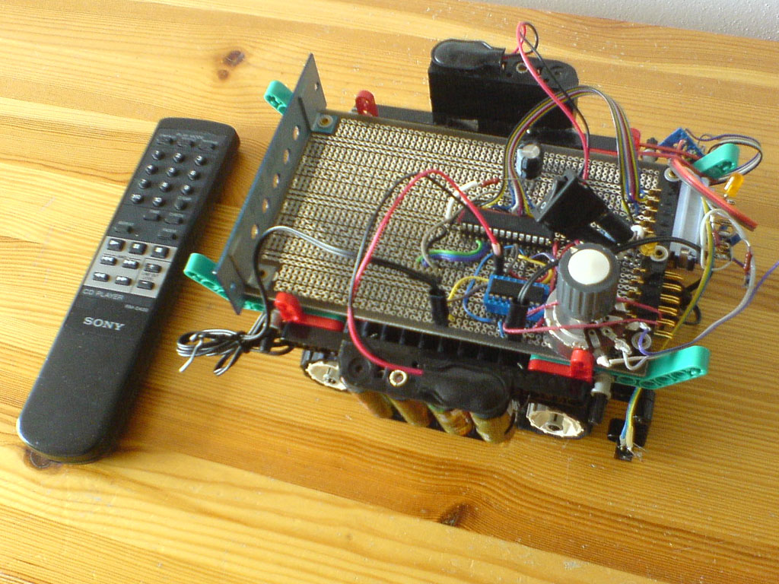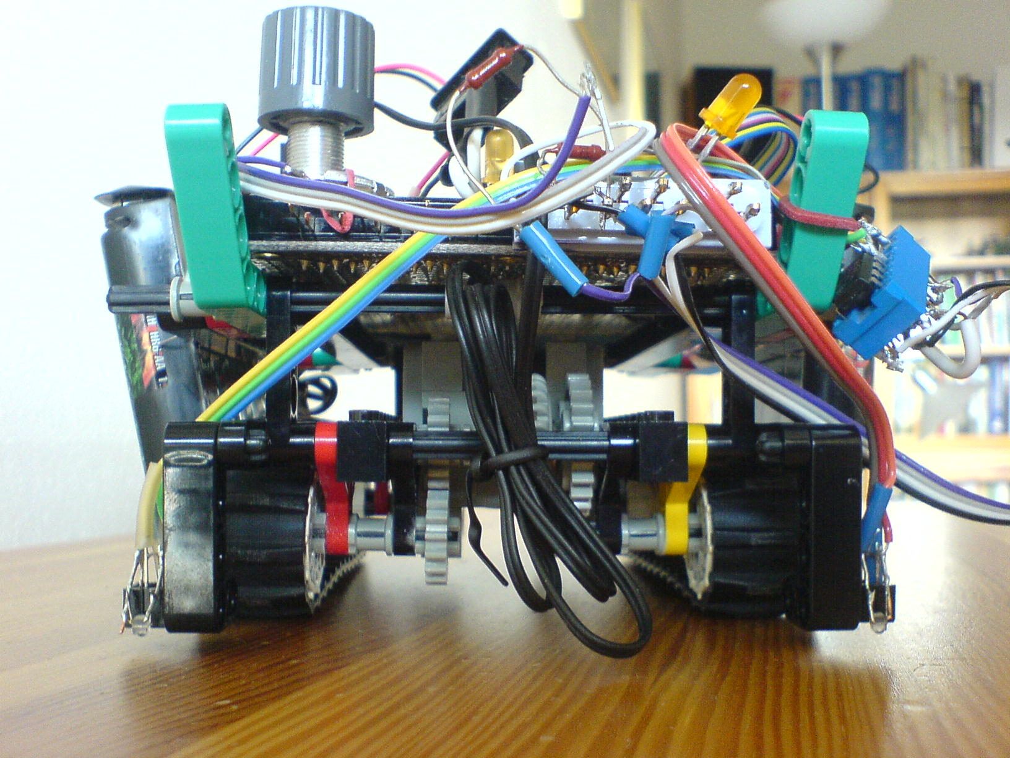
Figure 1: my first robot
The robot had two optical sensors CNY70 [2] that were able to recognize the edge of surface on which the robot was moving. When the robot reached an edge of a table, it reversed and continued in another direction. Just to make sure that the robot will not fall over and smash itself on floor, I put infrared receiver SFH5110-38 into the robot. That allowed me to stop the robot with an IR remote control in case of sensor or program failure. In fact, for the first time I didn’t decode the remote control protocol, because it was quite difficult for me. The robot simply answered to any signal from any IR remote control. However it could not identify which button was pressed and sometimes the IR-receiver was interfered with by certain fluorescent lighting. Later I managed to decode the protocol completely, so my next robots were able to recognize pressed button. I soldered the robot’s components to an etched prototyping printed circuit board. This board is not so flexible, but it is more reliable than breadboard.

2.1 designing a circuit board
After many experiments on a prototyping board, when I found an already working circuit, I decided to create my own compact etched board because the prototyping board was too big for my robot. I designed the circuit scheme in program EAGLE [14] and then I generated a plan of the circuit board. It is very interesting how the program EAGLE works. You only have to place the components on the board and the EAGLE makes the connections between components in a way that no wire crosses any other. You must place the components advisedly to simplify the final board and to reduce the number of unlinked points. As it was my first board, I decided to make it only single-sided. However, several points could not be linked on one-sided board and I had to connect them manually with a wire. The Light version of EAGLE is free, but it allows you to make the boards not bigger than 8 × 10 cm (These measurements were enough for my project). The number of components is not limited in the Light version.

Figure 2: Designing a board in EAGLE

2.2 making a circuit board
I redrew final plan using etch-resistant ink to a copper sheet laminated onto a non-conductive substrate. Then I sank the board into the FeCl₃ that caused etching unwanted copper from the board.
After that I drilled holes for components into the board. And finally I soldered the components with a soldering gun. It is not good to solder integrated circuits directly into a board; it is better to put them into sockets. The integrated circuit can be then easily removed and replaced. External sensors, engines and power supply are attached to the board with keyed connectors.

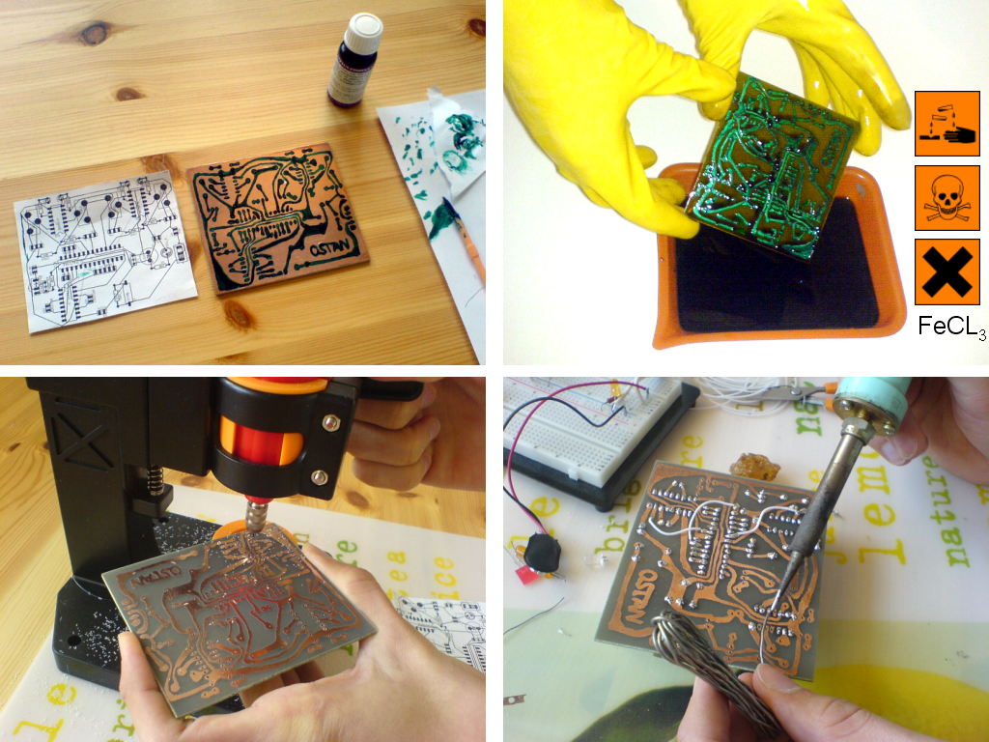
Figure 3: My first circuit board

2.3 line following robot
The robot´s undercarriage is made from Lego Technic brick-box, a well-known kit for children. Two independently working engines propel two back wheels. A smaller fore wheel conduces to all directions as the robot requires. I left the caterpillar chassis conception, because with wheels robot rides much faster. Four 1.2V NiMH batteries supply the robot. The undercarriage is fitted with a sensor module detecting a black line. Another two front sensors detect obstacles in the way.

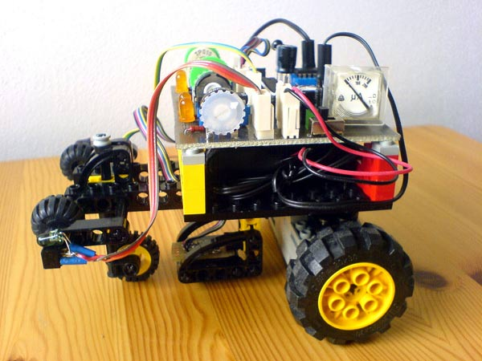
A front sensor
(CNY70 + extra infra LED)
A guideline sensor
(2x CNY70)
Figure 4: Robot´s main construction parts

2.4 Principles how a robot can follow a guideline
A robot seeks a guideline by riding on a spiral trajectory until it crosses. Even then the robot starts to follow a given guideline.
There are three fundamental situations that could happen:
1) Being on a line…  The simplest case is when both sensors are above a guideline and a robot follows it going straight on. | Figure 5: Being on line

2) Loosing a line…  Approaching a curve, a right sensor looses contact with a line. The robot unclutches its left engine, thereby it begins to turn left to return to the line. | Figure 6: Loosing a line

3) Outside of a line…  If a curve is too sharp (it means a robot’s turning radius is greater than a curve radius of the line), a robot can loose the guideline and it is outside of it. It changes the direction of the engine, which causes the robot to turn towards to the line. The sensors that are placed off axis get closer to the line...  The same situation could also occur at the end of the line. In such case the robot reverses at 180 degrees and turns back. | Figure 7: Outside of a line

2.5 Sensors
A black guideline and obstacles are detected by a set of reflective CNY70 optical sensors [2]. CNY70 sensors consist of an emitting light source and detector. Sensor locates existing barriers (object or surface) by using a reflective IR beam reflected by the barrier (see a figure):

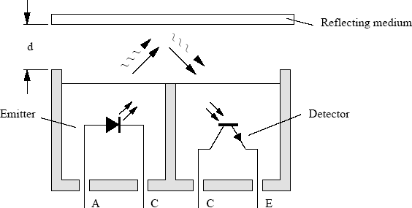
Figure 8: How an optic sensor CNY70 works
However, the built-in emitter with its light source is too weak to detect possible barriers so it is necessary to add an external IR LED with higher luminous intensity. Unfortunately, the sensitivity of CNY70 depends on an ambient light, a reflexivity of objects and of surfaces. Therefore it is necessary to calibrate the sensors manually. Each sensor is fitted with a potentiometer to control its sensitivity.
A guideline scanning module contains two CNY70s. A guideline designed and marked using a black PVC isolation tape cannot reflect infrared beams so it is easy for CNY70s to determine and distinguish (to read) a line by a light reflection of a surface.
CNY70s have a transistor output. An analogue signal from a sensor must be converted to a digital one, in order to be promptly processed by a microcontroller. There are many integrated comparators that can do it. I have chosen a dual timing circuit LM556CN for signal conversion:

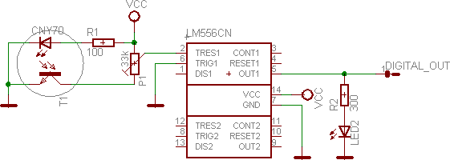
Figure 9: An analogue signal conversion (circuit diagram)

A phototransistor resistance depends on an amount of a reflected infrared light. The phototransistor is connected to a voltage divider along with a calibration potentiometer. When an infrared beam is reflected back to the sensor, the phototransistor resistance decreases and a voltage simultaneously decreases on TRESHOLD pin. As the TRESHOLD voltage falls bellow 2/3 VCC, the timing circuit switches OUTPUT to a logical 1, until the voltage grows up again. [5] LED2 indicates current circuit logical state.

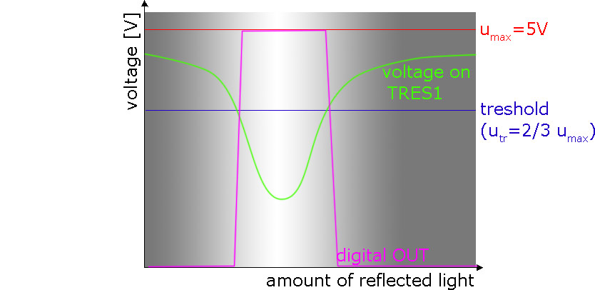
Figure 10: Reflected light vs. voltage

2.6 Characteristics of my robot
A robot (shown in Figure 4) behaves as I have planned. It is able to follow a marked guideline with a speed of 0.28 ms⁻¹. It can avoid collisions while scanning oncoming barriers. My robot can be controlled with a remote IR control. When it reaches an end of a line, it simply reverses on its way. In the case where guiding line is split the robot can chose a straighter way (the principle is similar to a tram track). The robot can follow any black line wide at least 10 mm.

REFERENCES
- Lunochod. <http://www.lunochod.wz.cz/lunochod.htm>
- CNY70 datasheet, Vishay Semiconductors. Available at: <http://www.ortodoxism.ro/datasheets/vishay/83751.pdf>
- L293D datasheet, ST Microelectronics. Available at: <http://www.ortodoxism.ro/datasheets/stmicroelectronics/1330.pdf>
- BERNARD, J.-M. (1982) Od logických obvodů k mikroprocesorům. Praha, SNTL.
- KAVÁLEK, J. (1996) 555C++ Praktická příručka pro konstruktéry. Epsillon, pp. 18-22. ISBN 80-902011-2-1
- MATOUŠEK, D. (2006) Práce s mikrokontroléry Atmel AVR ATmega16. Praha, BEN – technická literatura. ISBN 80-7300-174-8
- NOVÁK, P. (2005) Mobilní roboty. BEN – technická literatura. ISBN 80-730-141-1.
- BURKHARD, M. (2003) C pro mikrokontroléry. BEN – technická literatura, ISBN 80-7300-077-6.
- Simple ISP programmer schematic: http://www.qsl.net/ba1fb/avrisp.gif
- PonyProg homepage: http://www.lancos.com/
- Jednočip, to je ono! [on-line]. [cit. 11.11.2007]. <http://bezstarosti.cz/elec/jednochip/jednochip.htm>
- AVRBeginners.net. <http://www.avrbeginners.net/>
- Mikrocontroller.net. <http://www.mikrocontroller.net/articles/AVR-Tutorial>
- JANÍK, P. Eagle návod [on-line]. [cit. 11.11.2007]. <http://paja-trb.unas.cz/elektronika/eagle/eagle_navod.html>


Biography
Ondřej Staněk (18 age)
I am a secondary school student of the Gymnasium Na Vítězné pláni in Prague 4, Czech Republic. I am interested in computer programming, electrotechnics, computer graphics, web pages design and recently also in robotics. Since June 2007 I have been developing autonomic robots. I presented my first robot on the student projects exhibition in December 2007 organised as a part of the ESF project “SCIENCE” that was managed by the Faculty of Maths and Physics, Charles University in Prague. There I gained the prize for the best student project awarded by a professional committee.
My homepage: http://www.gvp.cz/~ostan/

Copyright
This work is licenced under the Creative Commons Attribution-NonCommercial-NoDerivs2.5 License. To view a copy of this licence, visit http://creativecommons.org/licenses/by-nc-nd/2.5/ or send a letter to Creative Commons, 559 Nathan Abbott Way, Stanford, California 94305, USA.

